**Berwick College Course Counselling - Instructions for Parents for Online Bookings**

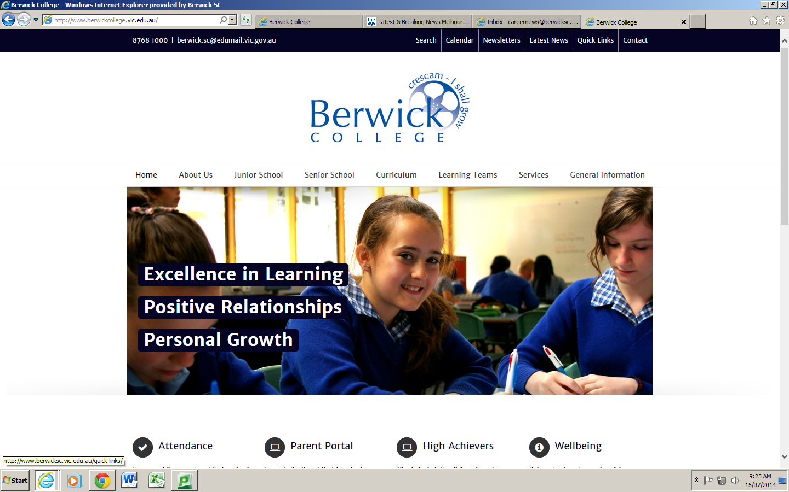

1. Go to our web site:

[www.berwickcollege.vic.edu.au](http://www.berwickcollege.vic.edu.au)

2. Click on **Quick Links**

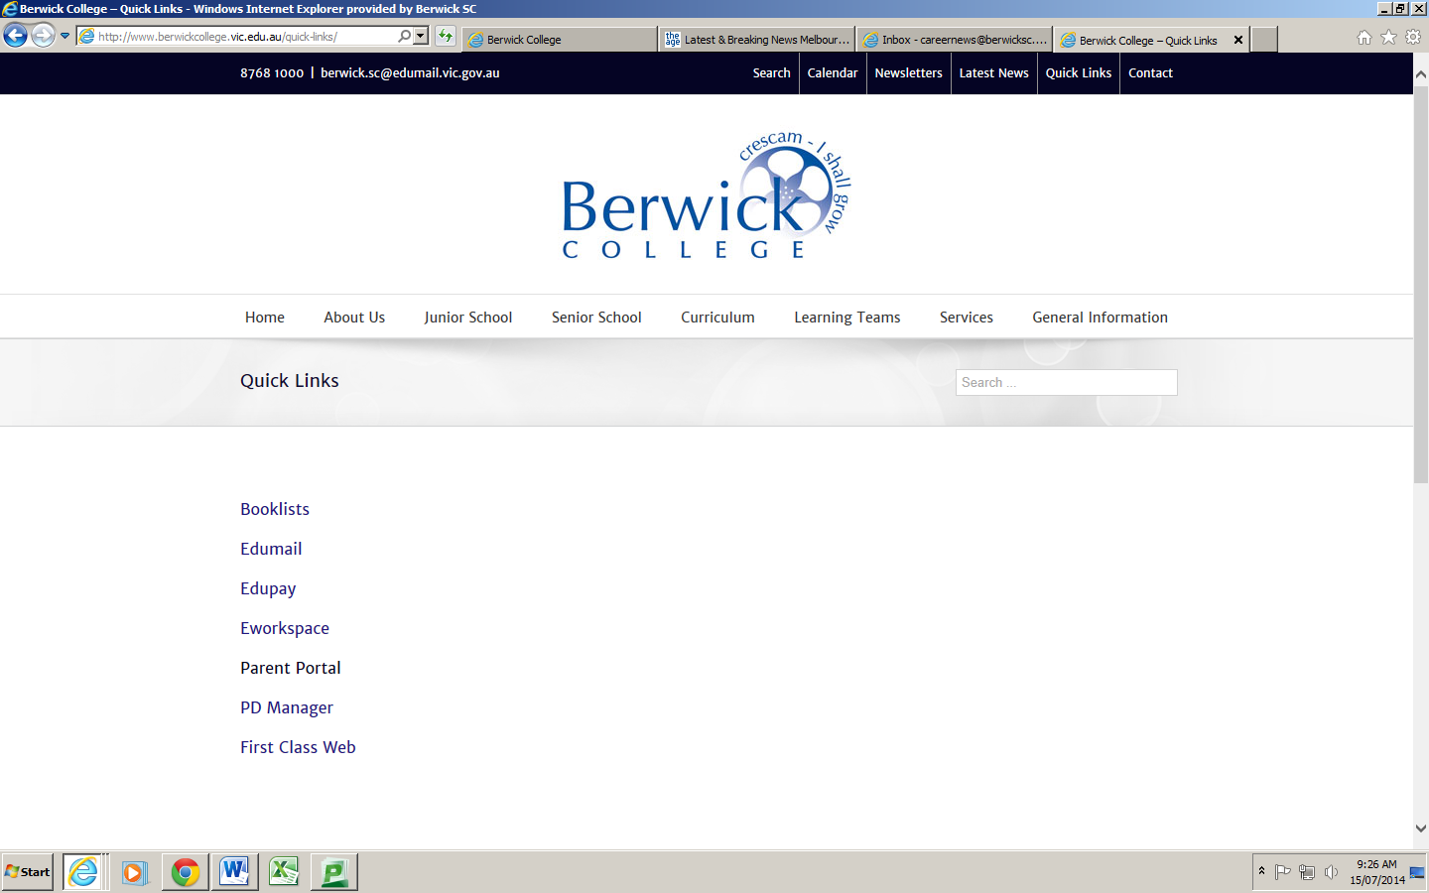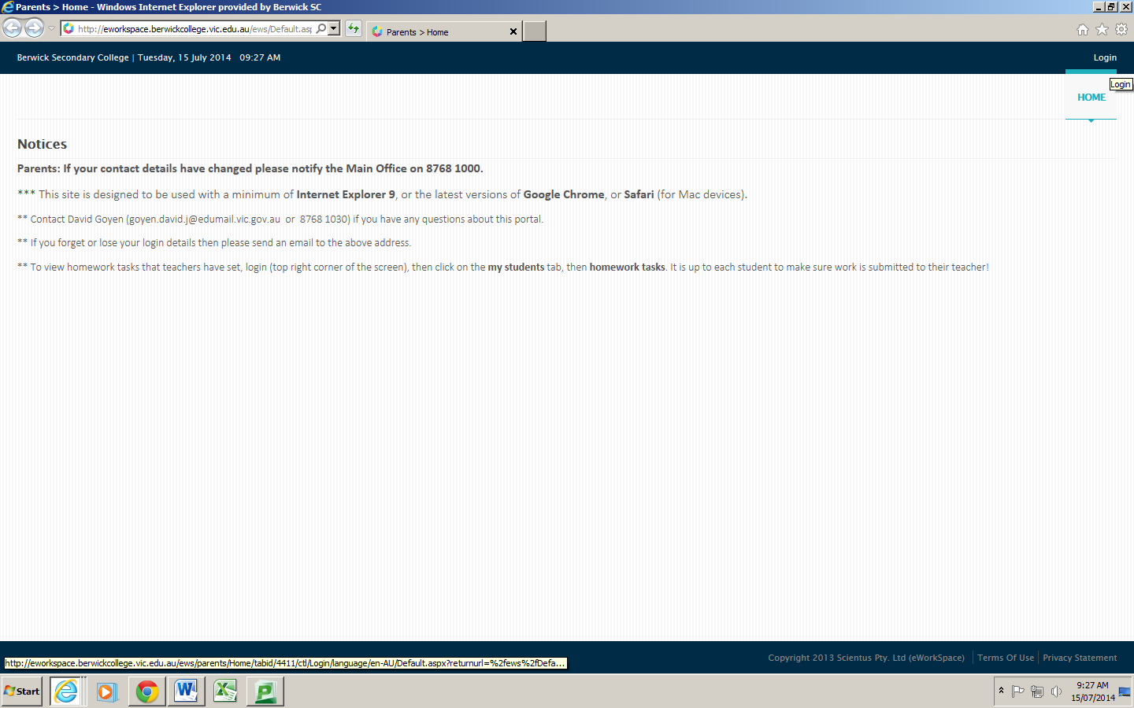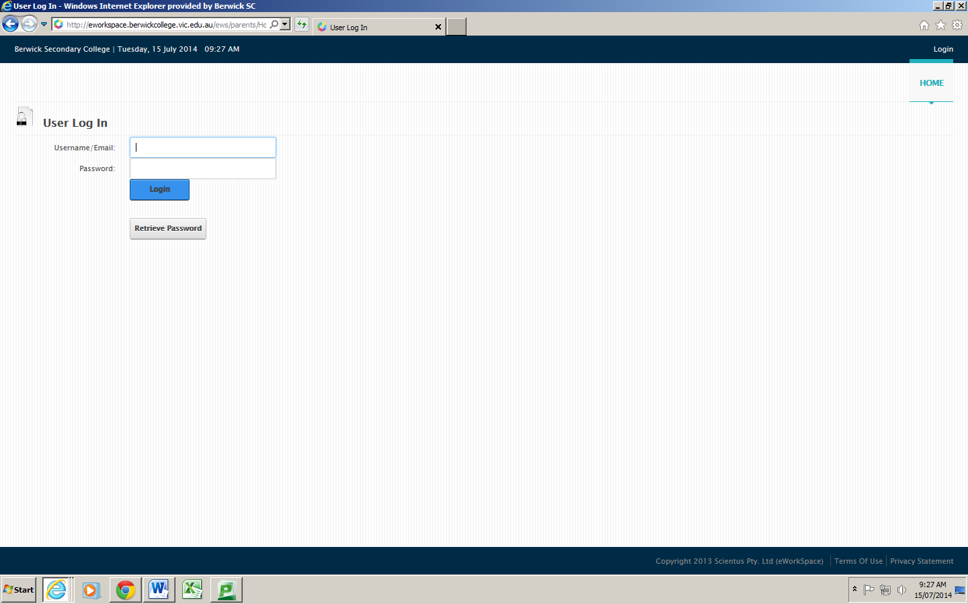

5. Enter your **Username** and **Password**.

4. At the top right of the screen click on **Login**.

3. Click on **Parent Portal**

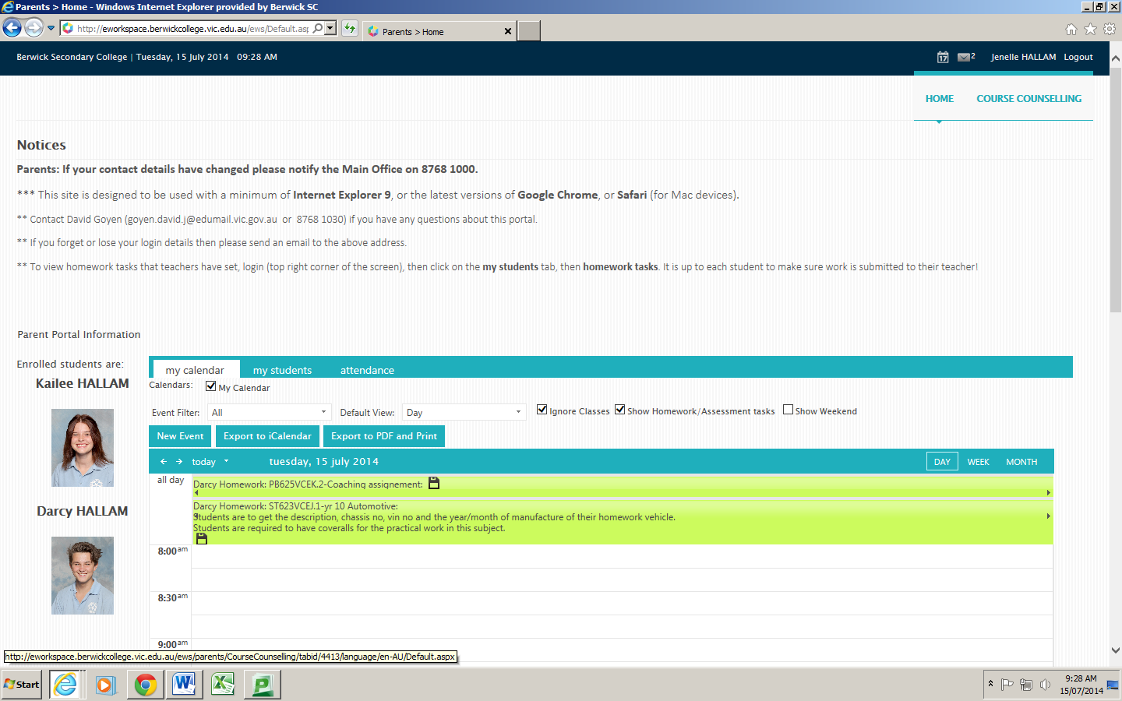

6. Your son or daughter(s) photo(s) will be displayed.

7. Click on **Course Counselling** at the top right.

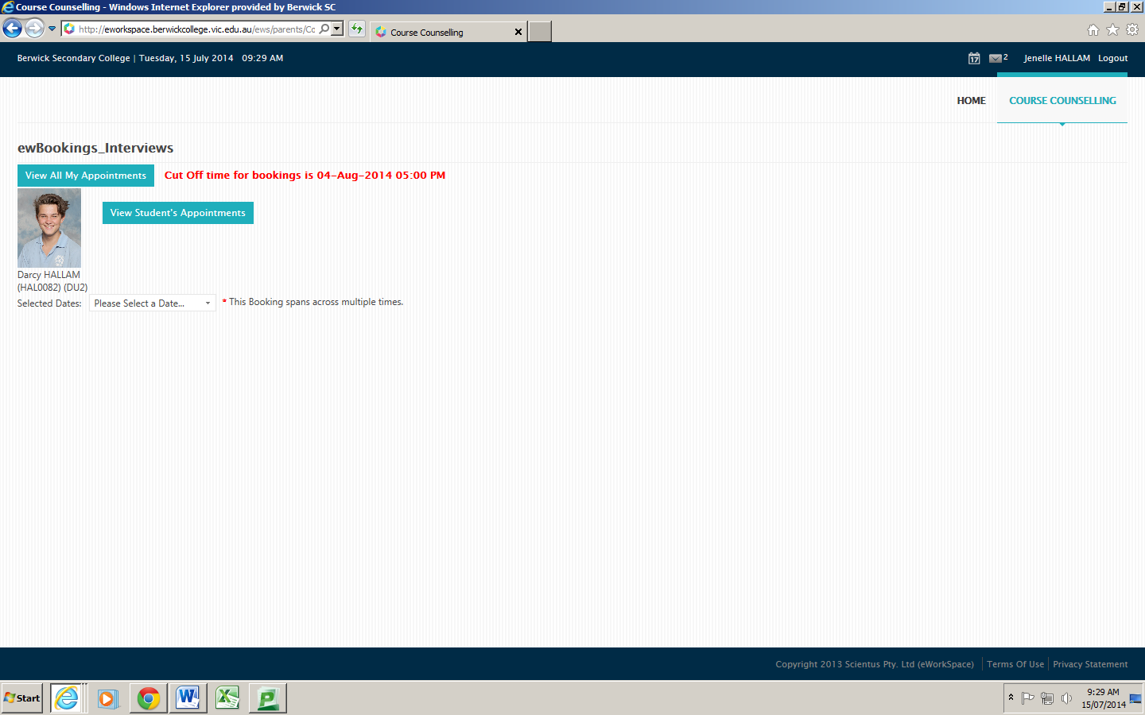

8. Choose the appropriate **date** according to the **Year level** of your child.

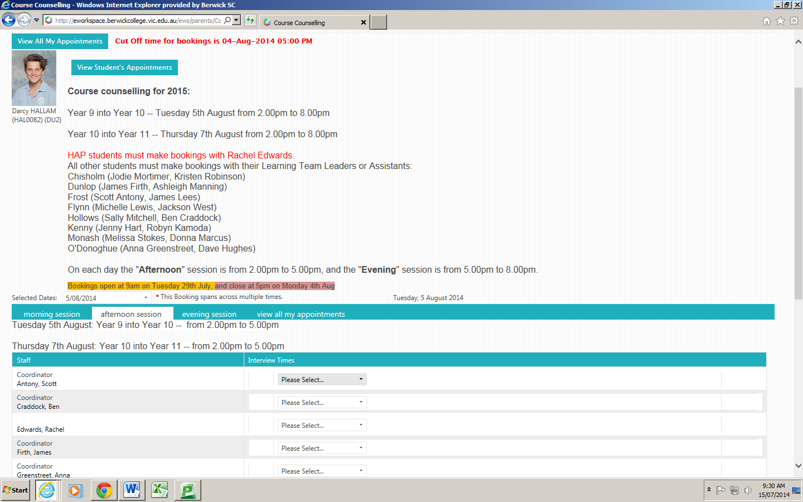

9. Parents of **HAP students** must make bookings with Rachel Edwards.

For all other students you need to know the name of their **Learning Team** so you can make a booking with the appropriate staff member(s).

10. **Select a time** from the drop down list next to the appropriate staff member. Note that there is a separate tab for each of the Afternoon and Evening sessions.